From the graph we can infer that number of iterations drastically reduced from 9888 to 1205 when over relaxation factor is reduced from 1.1 to 1.9 in the step of 0.1. Next we investigate the above variation in the zoom out domain of 1.9 to 2 by increasing the over relaxation factor in a step of 0.01.

We can see from the above graph that Number of iterations reduces to a minimum and then again increases. The over relaxation factor value at which we obtain least number of iteration is 1.95. So the value of ω optimum is:

**ωopt = 1.95**

**Table 1: Comparison of Solution of Algebraic Equation Method with the initial guess of temperature field taken as 0oC**

|  |  |  |
| --- | --- | --- |
| **METHOD** | **NUMBER OF ITERATION TILL CONVERGENCE** | **EXECUTION TIME REQUIRED TILL CONVERGENCE** |
| Point Gauss Siedel | **11285** | **14** |
| Line Gauss Siedel (TDMA) | **5901** | **9** |
| PSOR at ωopt = 1.95 | **376** | **1** |
| ADI | **3050** | **7** |

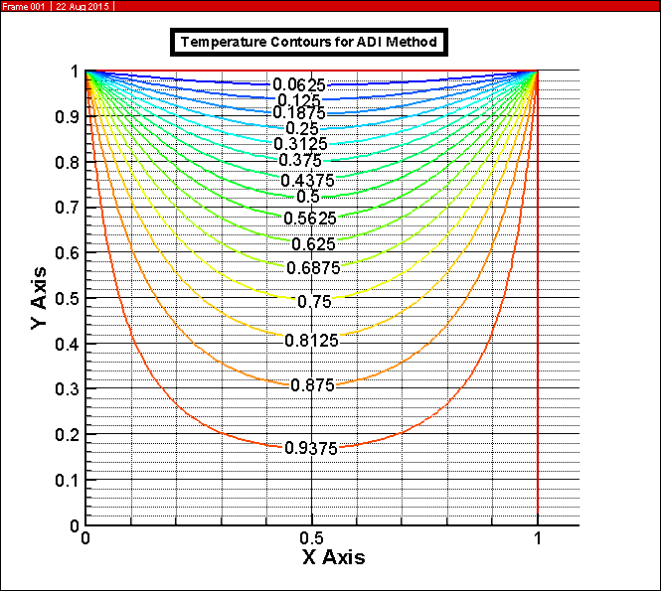

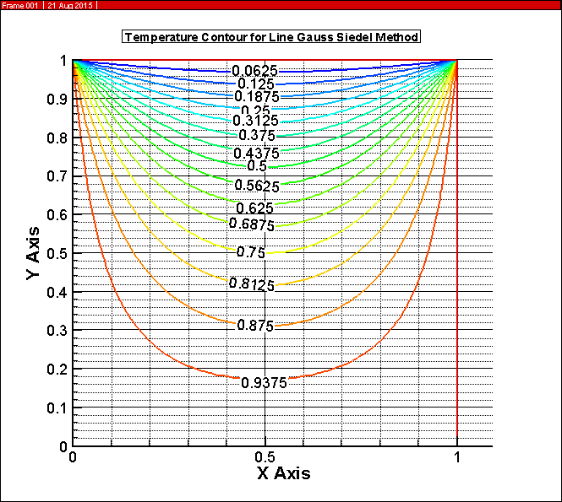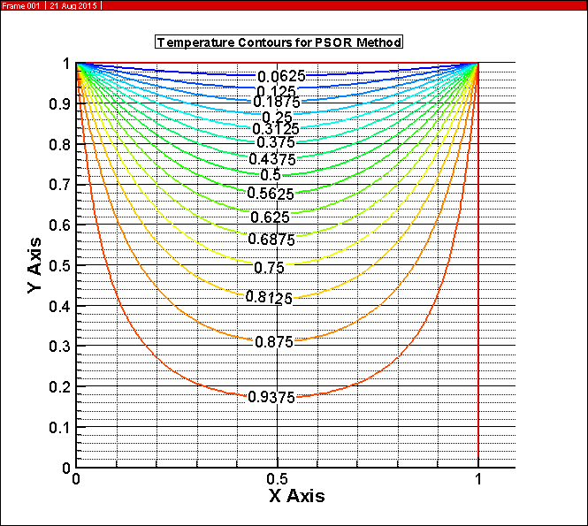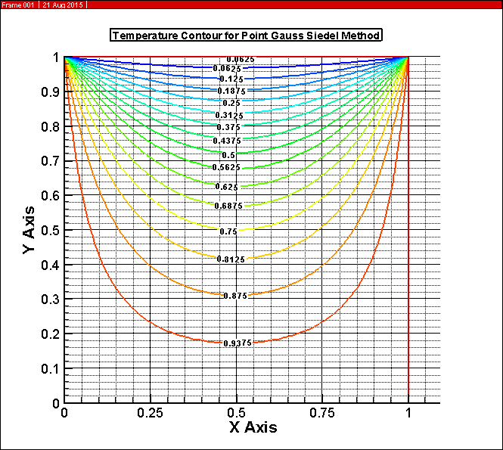 **Figure 1: Temperature Contours obtained for Different Solution Methods**

**Table: Discretised Algebraic Equation for Different Solution Method**

|  |  |
| --- | --- |
| Point Gauss Siedel |  |
| Line Gauss Siedel |  |
| Point Successive Over Relaxation Method |  |
| Alternating Directional Implicit Scheme | X sweep:  Y sweep: |